Figures and Tables for Ch 1, AR Forecasting of Phytos

* Intro
  + Table 1. Summary of literature review targeting studies using ecological forecasting methods
    - Use this table to justify the use of empirical methods
    - Statistical and simple process-based, check out what are the methods
    - Maybe table could include timestep, num of variables, training dataset
    - Supplemental table? Authors may be reviewers!
  + Conceptual figure summarizing a forecast development? Like the one from my committee meeting/ESA presentation. Might be useful if publishing in a journal that doesn’t typically have forecasting?
  + Uncertainty figure? Check out Ann Raiho (student of Jason maclachlan’s)
* Methods
  + Figure 1. Map of study site
    - Will show site 50 where catwalk sensors are, dam where met sensors are, and inflow where discharge sensor is
  + Table 2. Summary statistics of historical and sensor datasets
    - Min, max, median, mean of candidate driver data and response (CTD/EXO chl—report in CTD or EXO units?)
    - Met data stuff from edi, catwalk data from Thomas et al
    - maybe in supplement with super detailed product info
    - conversion from exo to ctd
  + Figure 2. FLARE Workflow
    - See picture from what we made during meeting
  + Table 3. Equations and descriptions of uncertainty contributions (process, parameter, etc.)
* Results
  + Figure 3. Model training period and observed dynamics (Q1)
    - 3 lines, one for each model with R2 and RMSE printed in the figure caption?
    - They all did ‘equally’ well, but chose the most parsimonious model to use in forecasting framework
  + Table 4. Model Assessment Results (Q1)
    - Include null models and mean forecast for 1 and 2 week predictions
  + Figure 4. Observed and forecasted chl dynamics for Model I from 15-Aug 2019 to 15-Jul 2019 (Q1)
  + Figure 5. Contributions of uncertainty as a proportion
  + Figure 6. Relative proportions of uncertainty contribution over time
* Supplemental
  + Figure 7. Parameter changes over time

|  |  |  |  |  |  |
| --- | --- | --- | --- | --- | --- |
| Table 1. Summary of literature review targeting studies using ecological forecasting methods. | | | | | |
| Authors & Year | Approach | Best Model | Ecosystem | Forecast Product | Use of forecast product in decision making (Y/N) |
| Araújo et al., 2005 | Uses multiple empirical models to assess uncertainty in projections | Empirical | Terrestrial | Bird species ranges | N |
| Brown et al., 2013 | Coupled process-based and empirical model to predict water quality | Process-based and empirical | Temperate estuary | Chesapeake Bay water quality | Y |
| Dean et al., 2004 | Combines climate projections and process-based model to make probabilistic projections | Process-based | Central highland forests | Carbon sequestration in forests | N |
| Estes et al., 2013 | Comparison of empirical and process-based models | Empirical | Agricultural dryland | Productivity and suitability of crops in South Africa | N |
| Gonzalez-Benecke and Martin, 2017 | Future projections of forest growth | Process-based | Southern-temperate forest | Loblolly Pine projections | N |
| Hazen et al., 2017 | Coupled empirical models to produce habitat suitability forecasts | Empirical | Marine | 8-day forecasts of Blue Whale density | Y |
| Lindegren et al., 2010 | Forecast impacts of climate and fishing pressure on marine food webs | Process-based | Marine | Baltic cod dynamics | N |
| Martínez-Meyer et al., 2004 | Used machine-learning techniques to predict species distributions during past geological time periods based on current distributions | Empirical | Conterminous United States during the present and the Pleistocene Era | Ecological niches of mammal species | N |
| Perretti et al., 2013 | Compared forecast efficiency of mechanistic and empirical models | Empirical | Simulated and laboratory data for beetle species | Species abundance | N |
| Stow et al., 2003 | Compared forecast efficiency of two process-based and one empirical model | Process-based and empirical | Temperate estuary | Neuse River Estuarine water quality | Y |
| Thomas, M.K. et al., 2018 | Used an empirical approach to determine forecast efficiency at multiple time scale (hours, months, years) | Empirical | Freshwater | Phytoplankton dynamics | N |
| Thuiller et al., 2004 | Examined the sensitivity of an empirical model to restrictions in input driver data | Empirical | Temperate forest | Tree species distributions | N |
| White and Nemani, 2004 | Used a process-based model to determine the relative importance of meteorology and vegetation phenology | Process-based | Temperate forest | Soil water concentrations | N |
| Woodbury et al., 1998 | Quantified forecast uncertainties from climate driver data, forest condition, and quantitative relationships using an empirical model | Empirical | Temperate forest | Loblolly pine growth | N |

Figure 2. Forecasting framework workflow

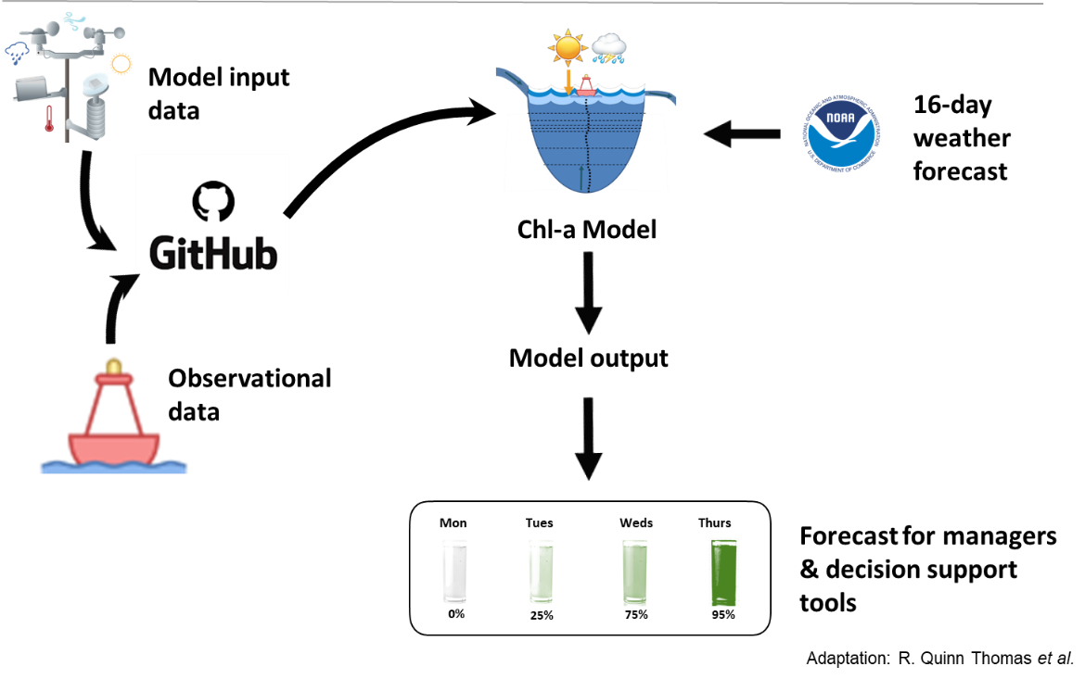

Table 3. Model Assessment Results

